Herbal Arthritis Remedy Really Works!
Devil's Club Soothing Rub and Healing Balm
We continue to sell our ever-popular Devil's Club Soothing Rub and Devil's Club Healing Balm. I get many re-orders from our Pioneers and their friends. The rub may now be in competition with CBD oil, but it is a lot cheaper!
After years of suffering constant knee pain from arthritis, I tried the salve on a lark, and realized 3 days later that the chronic pain was gone! Just rub a little bit on an aching joint, give it a half hour, and you'll find the pain gone, or at least lessened. You won't even have it to use every day. Many Pioneers continue to order Devil's Club and word is spreading about how well it works. Orders go out almost every week!
We don't make any medical claims about this salve, but I can tell you from experience it works! The salve is made from a native Alaskan plant, Devil's Club, and also includes poplar, spruce, wormwood, organic olive oil, beeswax, and pure essential oils. Devil's Club is also known as Alaskan ginseng and is prepared in Sitka, Alaska.
You only need to rub a small amount over the affected area for the Devil's Club to work. The 2 oz. jar should last several months. Works on sore joints, back, fibromyalgia, rheumatoid arthritis, Restless Leg Syndrome, Carpal Tunnel Syndrome, and more. Native Alaskans have used Devil’s Club for generations.
Devil's Club Healing Balm is an excellent all-purpose herbal healing salve with Devil's Club that promotes healing of cuts, abrasions, rashes, poison ivy (takes the itch out and dries up overnight, if you use it right away), eczema and burns, including sunburn. It provides relief from jellyfish stings, diaper rash, and many insect bites. Diabetics have made this their preferred treatment for the skin complications from diabetes. It is also great for fingers that have cracked skin from the cold winter weather.
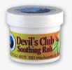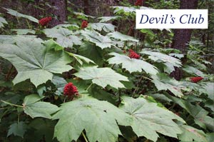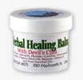
Order now. Cost is $14.84 including tax for 2 oz. jar. Add $7.50 shipping (for 4 to 8 jars total). I jar in bubble envelope add $3.75 shipping, 2 jars add $4.75
Devil's Club Soothing Rub_____________ Devil's Club Healing Balm____________
NAME_________________________________________________________
ADDRESS_______________________________________________________
_______________________________________________________
TN (inc. area code)_______________________________________________
Email___________________________________________________________
Make check out to TP#7. Mail to: Leni Herr, 48 Sunrise Dr., Englewood, FL 34223
Call with any questions 610-451-9058 or email LeniHerr@aol.com

